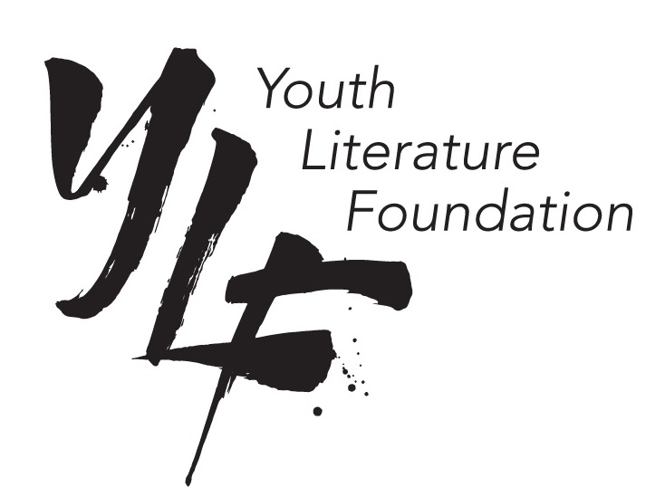
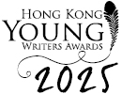

The Hong Kong Young Writers Awards 2025 – Primary and Different Learning Ability Schools Only

Cover Art – Cover Sheet

Student Name:

School Name:

Teacher:

